PROJECT REPORT



**405 Found**

CS 301

# 

**Contents**

1. Introduction
2. Project Description
3. Design
4. Implementation
5. Testing
6. Conclusion
7. References
8. Contributions

# 

# INTRODUCTION

The purpose of this report is to provide an overview of our project that aims to create a community-based Q&A platform for coders. The platform will provide various social features and resources related to coding to enable like-minded individuals to share their knowledge and expertise, seek mentorship, and help each other with coding-related queries. The platform will support the creation of communities based on specific coding languages or topics, allowing users to connect with others who share similar interests.

# PROJECT DESCRIPTION

The Q&A platform will provide an easy-to-use interface for users to browse and post social content, ask questions, browse previously asked questions, and submit answers. Users will be able to upvote and downvote content and answers, promoting the most helpful and accurate information. The platform will also support the use of tags to categorize content and make it easier to find.

In addition to traditional Q&A features, the platform will allow users to post other social content related to coding, such as articles, blogs, and videos. This feature will enable users to share their knowledge and opinions on various coding-related topics and keep up-to-date with the latest trends and technologies in the field. The platform will also include a feature to read tech news, making it easier for users to stay informed about the latest happenings in the tech industry.

To further support the growth and development of its users, the platform will include a mentorship feature. Users can search for mentors based on their level of experience and areas of interest, and send mentorship requests to those they think are suitable. The platform will also allow users to offer themselves as mentors, enabling them to connect with mentees who share similar interests and goals. The mentorship feature will include a messaging system to facilitate communication between mentors and mentees.

To encourage user engagement, the platform will include a gamification element that allows users to participate in contests and daily quests to earn credits. These credits can be used to purchase courses or other rewards. The platform will also include a leaderboard to display the top performers, further incentivizing users to participate.

The platform will be built using various programming languages and frameworks and may integrate with third-party tools and APIs to provide additional functionality. The project team will prioritize user experience and ensure the platform is scalable, secure, and easy to maintain.

In conclusion, the Q&A platform will provide a valuable resource for coders of all levels to learn, share, and grow their coding skills. With a range of social features, tech news resources, and a mentorship program, the platform will create a thriving community of coders that is both engaging and informative.

# DESIGN

The platform was designed using Figma, a collaborative design tool. The design process involved creating wireframes, testing user flows, and building a final design prototype.

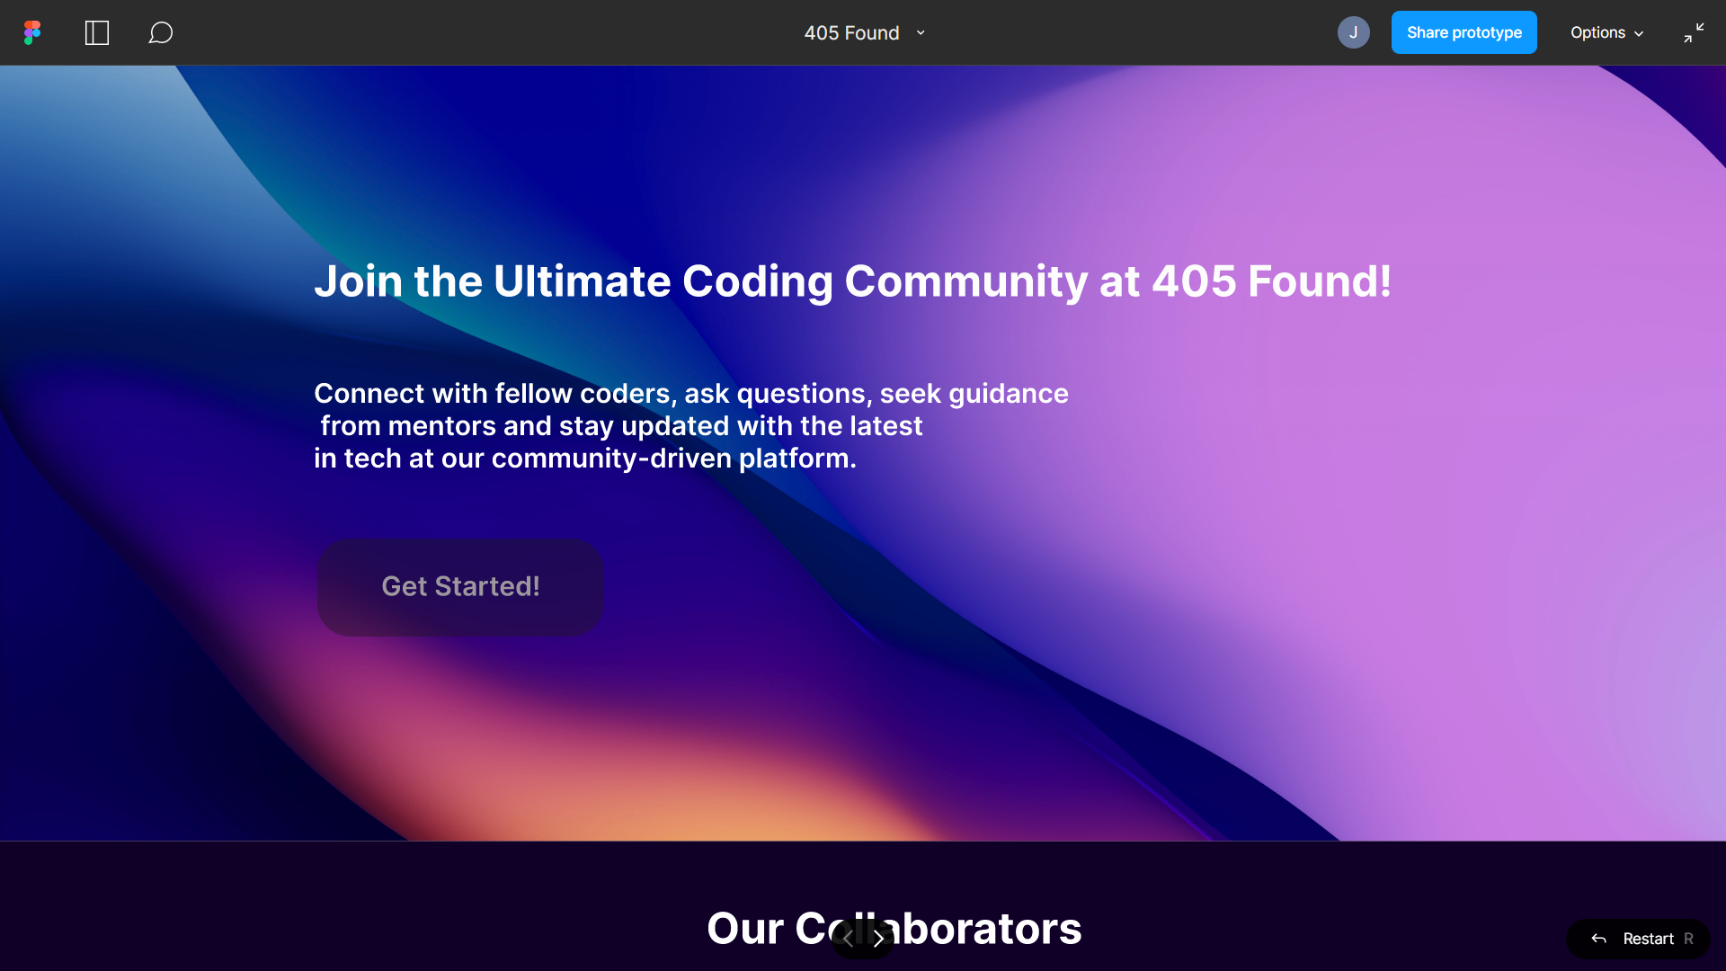

This is the design for the landing page of our website. You can click on get started to get the sign up form.

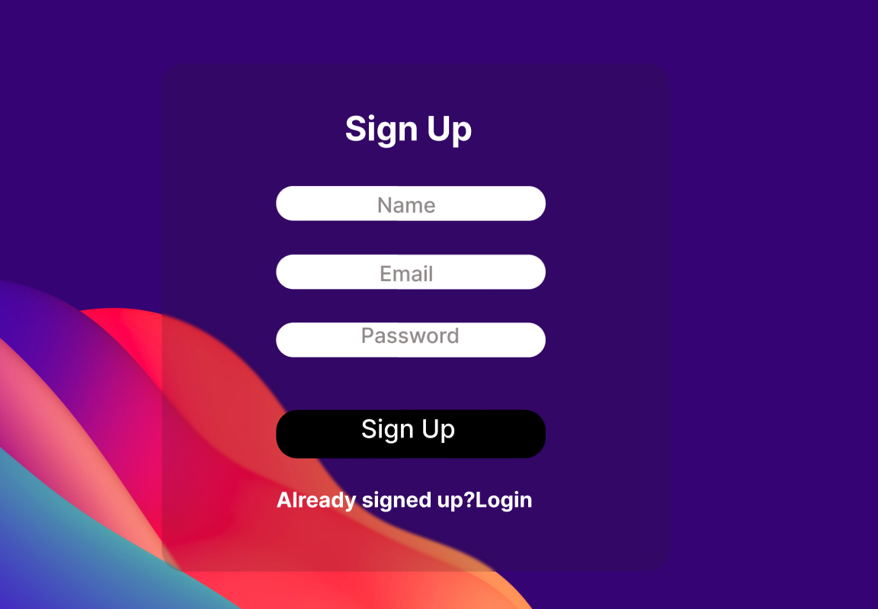

After signing up or logging in, you will get the home page.

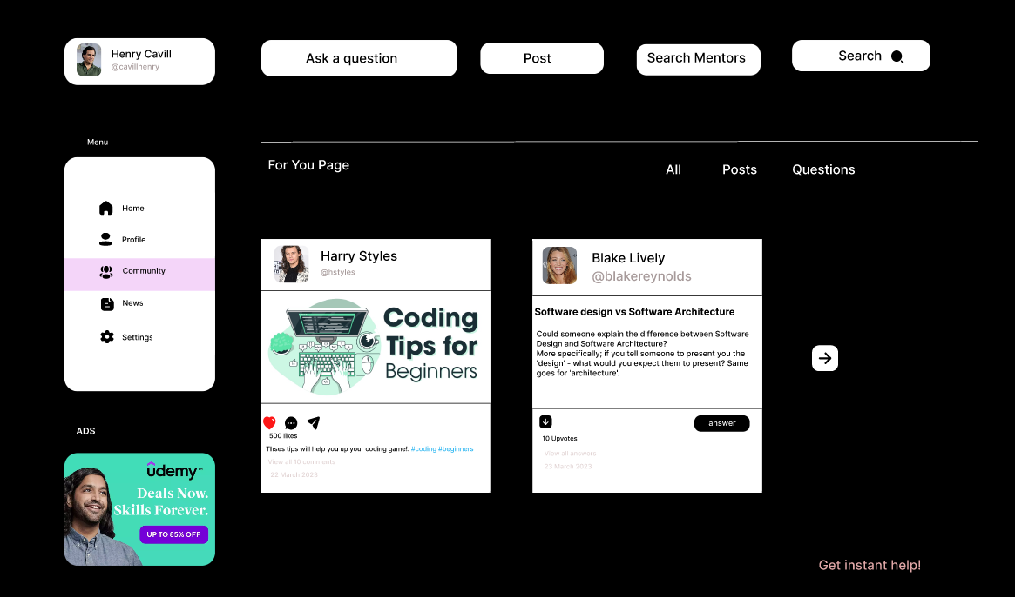

Here you can see a menu option that includes various options. The For You page will include posts and questions based on the interests of the user. Clicking on Community will lead to the following page. You can choose posts if you only want to see posts and questions for only viewing questions. On clicking Community in the menu, You will get the following page.

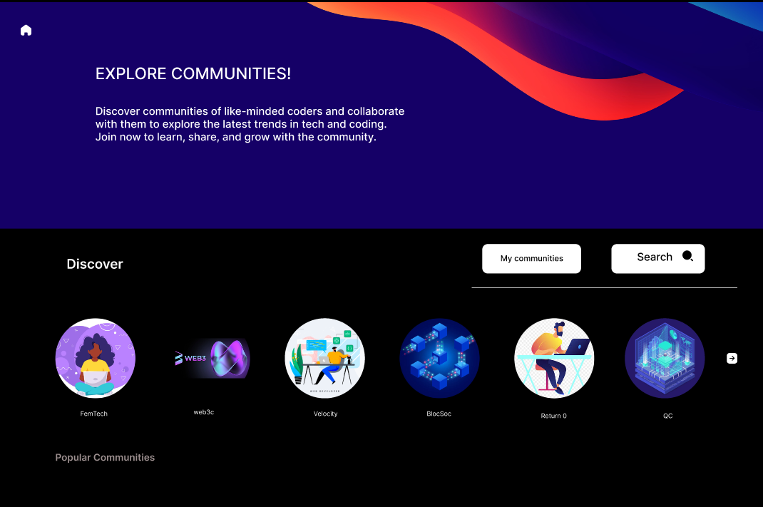

This page is the discover community page and you can click on any community to view their profile (In the figma description, On clicking FemTech you can view the community profile and the same template will be followed for all the other communities as well).

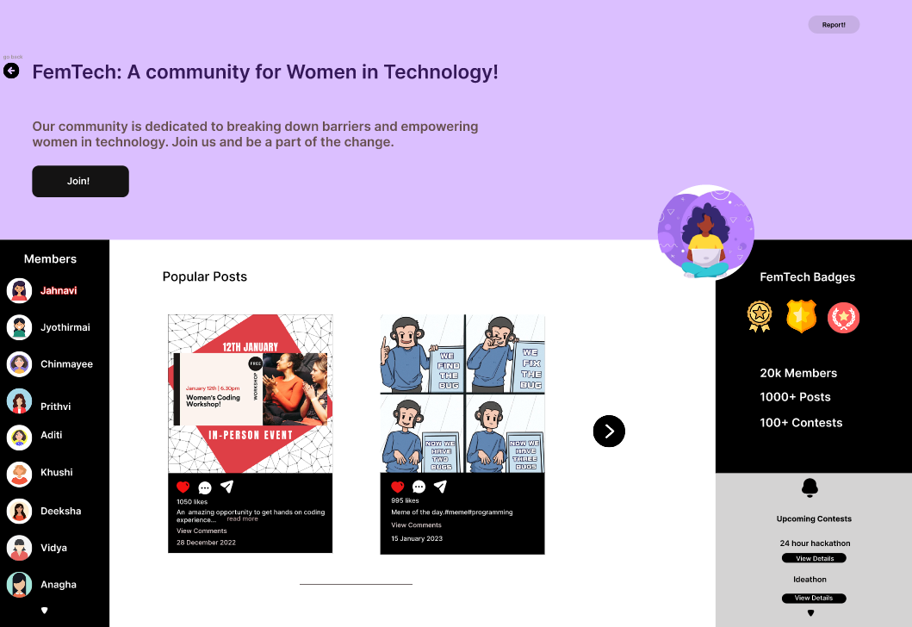

This is how the community profile will look like for all the communities.

In the discover page if you choose the My Communities option you should get the following page.

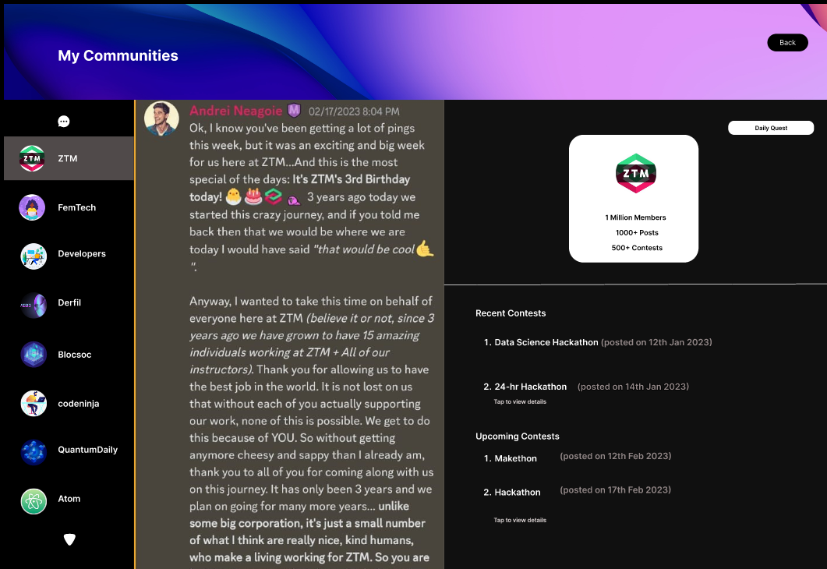

This page will include the communities that the user has joined. It will have a chatbox feature to communicate with the community.

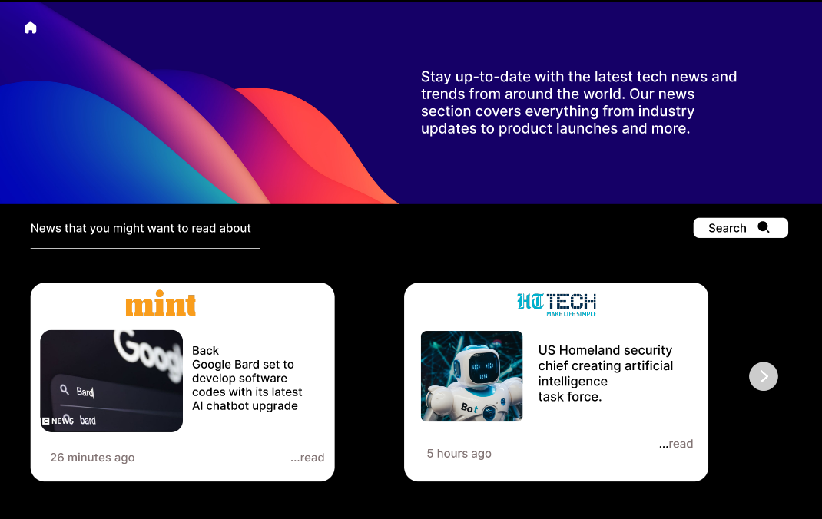

This will appear when the user clicks on news. The news section includes tech news that the user might be interested in and also a search bar to search specific news.

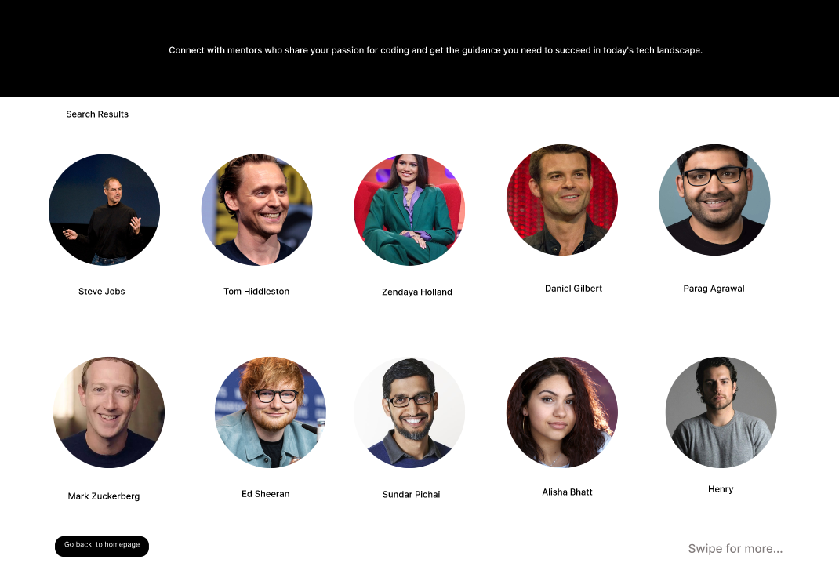

This type of page will appear based on your search in the search mentor option. (The profiles here are just for design purposes). On clicking the profile you will get their descriptions.

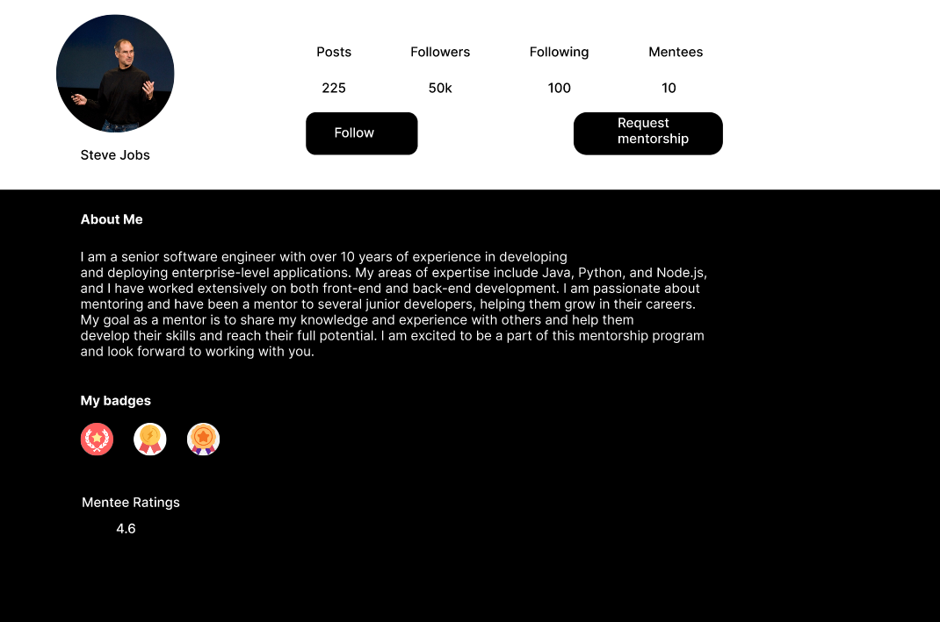

This is the profile format for mentors. The about me section will give the user who is seeking mentorship, a brief idea about the mentor. Also if their profile resonates with the user, they can request mentorship.

Link to the figma file : <https://www.figma.com/file/XM73GqadvRrzTcMQoaIdPI/405-Found?node-id=0%3A1&t=qpNk8af6KA2wd1Sq-1>

# IMPLEMENTATION

**Overview of the Implementation process**

During the implementation process, we used a combination of technologies to build our social media platform for coders. The primary technology used for backend development was Django, a popular Python web framework. For frontend development, we used HTML and CSS to create an attractive and user-friendly interface. In addition, we utilized several APIs to connect our platform with external services.

The development environment used for this project consisted of Sublime as the integrated development environment (IDE) and Git for version control. We followed industry-standard coding practices, such as writing clean and maintainable code, and followed the Model-View-Controller (MVC) design pattern. In addition, we plan to deploy the application on AWS, which provides a scalable and secure platform for hosting web applications.

**Functionalities of the technology we have used:**

* Django: A high-level Python web framework that allows for rapid development of secure and maintainable websites. It provides various built-in functionalities such as authentication, URL routing, and database modeling.
* HTML: A markup language used to create the structure of web pages. It is the standard language used for creating websites and provides the basic building blocks for web development.
* CSS: A stylesheet language used to describe the presentation of a document written in HTML. It is used to define the layout, colors, fonts, and other visual aspects of a web page.
* APIs: Application Programming Interfaces allow different software applications to communicate and interact with each other. APIs can be used to connect different web services and databases to your website, allowing for increased functionality and integration.
* Sublime Text: A popular text editor used by programmers to write code in various programming languages. It provides syntax highlighting, autocompletion, and other helpful features to aid in coding.
* AWS: Amazon Web Services is a cloud-based platform that provides a variety of computing services, including hosting and deployment of web applications. It allows for scalability, reliability, and easy management of web servers.

**Challenges or Roadblocks:**

1. Integration issues: During the implementation phase, we faced some challenges in integrating different technologies and APIs due to the lack of proper documentation and different vendors involved. This made it difficult to ensure smooth integration and led to some delays in the development process.

2. Security concerns:As a social media platform, we understand that the security of user data is of utmost importance. We have implemented strong security measures such as encryption, user authentication, and access control to ensure the protection of user information and prevent unauthorized access. Regular security audits and testing are conducted to identify and address any potential vulnerabilities or weaknesses in the system to ensure a secure environment for our users.

3. Compatibility issues: During the implementation phase, we faced the challenge of ensuring compatibility between the different technologies we used. For instance, we encountered issues with the integration of certain APIs and libraries, which required extensive troubleshooting and debugging. Additionally, we had to ensure that our application was compatible with different web browsers and devices, which required testing and adjustments to the code.

4. Lack of documentation: Lack of documentation can be a challenge when working with third-party APIs or libraries. This can make it difficult to understand how to use them or to troubleshoot issues that arise.

5. Time constraints: During the implementation phase, one challenge we faced was time constraints. We had only four months to understand, study, and learn the technologies used before implementing them. This put pressure on us to work efficiently and meet the project deadline, which sometimes led to rushing our work and potentially overlooking certain details.

6. Technical expertise: During the implementation phase, one of the challenges we faced was the level of technical expertise required to implement certain features using the technologies we were working with. As we were new to these technologies, there was a steep learning curve, and it took us some time to get up to speed. However, we were able to overcome this challenge by working together as a team, supporting each other and sharing our knowledge and experience to build the website. Through this process, we were able to develop our technical skills and gain valuable experience in implementing complex features.

Please see this link for additional details on our implementation.Our source code can be accessed here.

<https://github.com/JyothirmaiSuravarapu/social_media>

# TESTING

In testing our social media platform, we followed a comprehensive approach to ensure that the application was functioning as intended and meeting our requirements.

We conducted both manual and automated testing to cover a range of scenarios and identify any bugs or issues. Manual testing involved Jahnavi manually testing the application to verify that all the features were working as expected and there were no issues with the user interface.

We also used automated testing tools to automate the testing process and increase our efficiency. This included unit testing, integration testing, and end-to-end testing to verify that the application was working correctly at different levels.

In addition, we used various testing techniques such as boundary value analysis, equivalence partitioning, and stress testing to ensure the application could handle various inputs and scenarios without crashing or malfunctioning.

Overall, by using a combination of manual and automated testing techniques, we were able to identify and resolve any issues before deploying the application.

# CONCLUSION

In conclusion, the implementation of our social media platform was a challenging but rewarding experience. Throughout the development process, we encountered various roadblocks such as compatibility issues, performance concerns, and security risks. However, by working together as a team and following industry-standard coding practices, we were able to overcome these challenges and create a functional and user-friendly platform.

Our social media platform has the potential to be incredibly useful for coders, particularly if it is integrated with a college community. By providing a space for juniors to connect with mentors in seniors, share hackathon information, and stay up to date with club activities and events, our platform could help bridge the gap between different levels of coding expertise and facilitate a more collaborative and supportive coding community.

Overall, we are proud of the work we have done on this project and believe that it has the potential to make a positive impact on the coding community. We are committed to improving our platform and adding new features in the future. For example, we plan to incorporate coding rooms where students can collaborate and work on projects together, as well as a ‘explain the error’ feature which will help beginners understand and troubleshoot common coding errors. We are excited to see how our platform will continue to evolve and make a difference in the coding world.

# 

# REFERENCES

1. ChatGpt
2. Academic journals, industry publications.
3. Official documentation from the technologies and APIs used in our project
4. Our survey report (We have uploaded the report survey in the same repository)

# CONTRIBUTIONS

1. Requirement Elicitation : Jahnavi(21bcs044) and Jyothirmai(21bcs123)
2. Feasibility study : Jahnavi and Jyothirmai
3. Prototype Design : Jahnavi
4. Implementation : Jyothirmai
5. Testing : Jyothirmai and Jahnavi
6. Ppt : Ankush(21bcs012), Jahnavi and Jyothirmai
7. Project Report : Jyothirmai, Jahnavi and Ankush